NASA SPACE APP CHALLENGE 2025
E-Cell, Nirma University
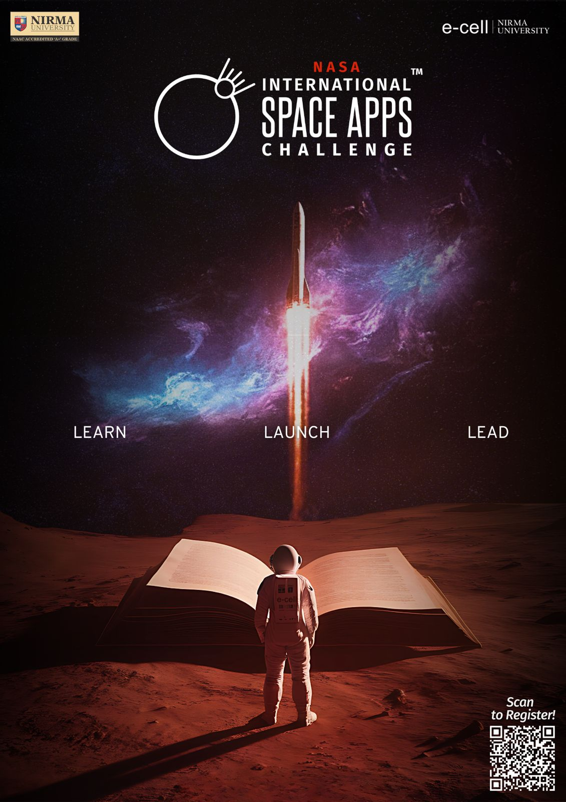

OVERVIEW
The NASA International Space Apps Challenge is the world’s largest annual global hackathon, organized by the National Aeronautics and Space Administration (NASA) in collaboration with leading international space agencies and partner organizations. The challenge brings together innovators, developers, designers, scientists, and students from across the globe to harness NASA’s open datasets and create innovative solutions for some of the most pressing challenges faced by our planet and the space community.
The theme for 2025, “Learn, Launch, Lead,” encapsulated the core spirit of the initiative — encouraging participants to learn emerging technologies and skills, launch bold and creative ideas, and lead their communities toward a sustainable and innovative future. The hackathon aimed to foster interdisciplinary collaboration, creativity, and data-driven problem-solving, enabling participants to translate knowledge into meaningful, real-world impact.

In alignment with this global vision, the Entrepreneurship Cell (E-Cell), Nirma University, proudly served as the Local Host for the NASA Space Apps Challenge 2025, held from 4th to 6th October 2025 at Nirma University, Ahmedabad. The event provided a dynamic platform where students, technologists, and innovators from diverse academic backgrounds came together to ideate, collaborate, and develop impactful solutions inspired by NASA’s challenge statements.

As the organizing body, E-Cell, Nirma University successfully cultivated an atmosphere of learning, experimentation, and teamwork throughout the 48-hour hackathon. Participants engaged with NASA’s vast datasets, developed working prototypes, and presented their ideas addressing critical issues related to Earth science, climate change, sustainability, and space exploration.

Supported by expert mentors and guided by a spirit of collaboration, the event truly embodied NASA’s vision of “innovation through collaboration.” It significantly strengthened the culture of innovation, research, and entrepreneurship within the university and reinforced Nirma University’s role as a hub of creativity and a proud contributor to NASA’s global innovation ecosystem.

FROM VISION TO EXECUTION-THE PRE EVENT JOURNEY

STRATEGIC PLANNING
The preparation for the NASA Space Apps Challenge 2025 at Nirma University commenced nearly one and a half months before the event. To maintain consistency and coordination, regular online and offline meetings were conducted among all team members, during which progress updates, timelines, and action plans were discussed in detail. The organizing team was divided into several departments — Marketing, Logistics, Content, Graphics, and Reachout — with each department assigned a Team Lead and Co-Lead to oversee their respective areas of responsibility. This structured approach ensured smooth communication, accountability, and efficiency in managing the large-scale event. Additionally, a group of dedicated volunteers was recruited to assist in various event operations, from on-ground coordination to registration and participant support, contributing significantly to the event’s success.

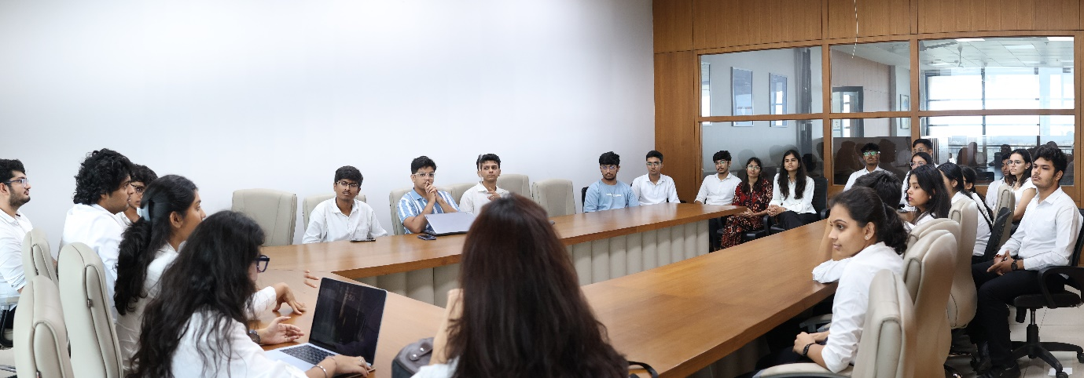
Pre event Meeting: Team E-cell

Logistics
The logistics team played a central role in managing all physical and infrastructural requirements. Their meticulous planning ensured the timely booking of venues, including the NIM Auditorium, C Auditorium, and several classrooms in the E Block, which served as workspaces for participating teams and mentorship sessions. They also handled the arrangement of essential resources such as sound systems, seating layouts, event signage, and refreshments, ensuring a seamless on-ground experience for both participants and guests. The logistics team coordinated closely with volunteers and other departments to ensure that all materials, equipment, and spaces were ready well in advance, thereby creating an organized and professional setup for the three-day event.

Content
The content was responsible for all formal communication and documentation related to the event. They prepared invitation mails for judges, mentors, university dignitaries, and the chief guest, maintaining an appropriate tone and structure in all correspondences. The team also drafted captions, WhatsApp floats, and Google Forms for participant registration, volunteer onboarding, and public announcements. By ensuring clarity and consistency in all written communication, the Content Team successfully reflected the professionalism and enthusiasm of the organizing body.

Marketing
The marketing team carried out extensive promotional campaigns to ensure maximum participation and visibility. Universities and colleges across India, including IITs, IIMs, PDEU, LJ University, LD College of Engineering, DAIICT, and Symbiosis University, were approached and invited to take part in the challenge. Along with inter-university promotions, Campus-to-Campus (C2C) marketing was conducted at institutes such as PDEU, DAIICT, and LJ University, where team members interacted directly with students to spread awareness about the event.
Within Nirma University, classroom visits and interactive sessions were organized to encourage participation by highlighting how the hackathon would enhance students’ skills, creativity, and exposure to global innovation. The team also leveraged digital media effectively by releasing a series of innovative Instagram reels, posters, whatsapp floats,official mails and event teasers, which generated widespread engagement and enthusiasm among the student community. To encapsulate the students,unique pop up shows were also arranged near K canteen.

Graphics
The team was instrumental in shaping the visual identity of the event. The team designed posters, digital creatives, ID cards, certificates, and banners, maintaining a consistent and visually appealing theme that aligned with NASA’s standards and the E-Cell’s branding. Their work extended beyond aesthetics — it contributed to creating a cohesive and professional image for the event, both online and offline. Every visual element, from promotional designs to stage backdrops, reflected creativity and attention to detail, enhancing the overall appeal of the hackathon.

Reachout
The reachout team played a vital role in connecting the event with distinguished individuals from academia and industry. The team successfully invited over fifteen mentors from diverse fields such as technology, entrepreneurship, and research, who guided the participants during the hackathon. They also coordinated the presence of an eminent Chief Guest and a panel of respected judges, whose insights added immense value to the event. The Reachout Team’s efforts not only elevated the stature of the event but also strengthened industry-academia relations, providing participants with a rare opportunity to engage with experienced professionals and domain experts.

Through this well-coordinated and collaborative effort, the pre-event phase set a strong foundation for the success of the NASA Space Apps Challenge 2025. Every department, supported by dedicated volunteers, worked cohesively to ensure that the event was executed with excellence.
DAY 1
Inauguration ceremony, Brainstorming,Mentoring session
Timings: 10:00 am to 6:00 pm
Venue: NIM Auditorium, E-Block Classroom

Registration
The NASA Space Apps Challenge 2025 at Nirma University began with an atmosphere of excitement and anticipation as participants arrived early to mark the beginning of this global innovation marathon. The registration of participants took place between 8:30 AM and 9:00 AM at E-block common area, during which over 500 students and innovators from leading institutes across India completed their registration and received their event kits and ID cards. The venue buzzed with energy as teams interacted, networked, and prepared themselves for the 48-hour hackathon ahead.

Inauguration Ceremony
The NASA Space Apps Challenge 2025 at Nirma University began with a grand Inauguration Ceremony at NIM Auditorium, marking the commencement of the three-day global hackathon. The event saw an overwhelming participation of over 500 innovators and students from across India, filling the auditorium with enthusiasm and anticipation. The ceremony opened with a prayer, symbolizing positivity, unity, and the beginning of an inspiring journey of innovation.
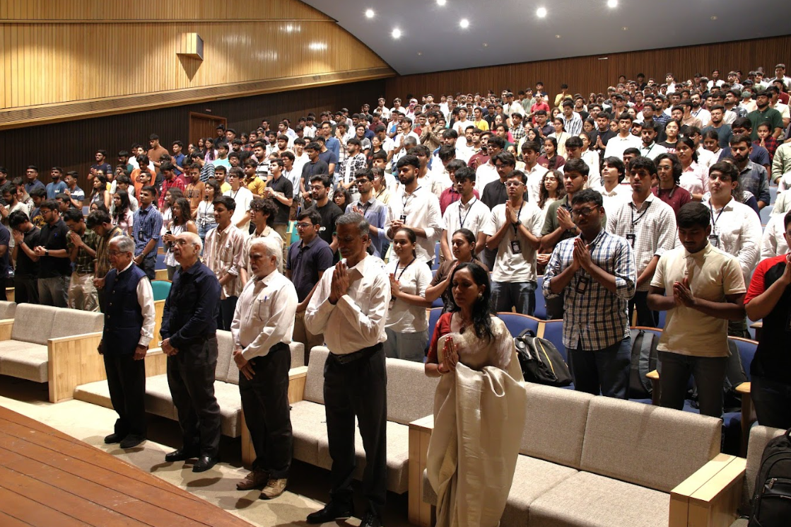
Inauguration Ceremony

The inauguration was graced by several distinguished dignitaries, including Dr. B. N. Suresh, the Chief Guest, Rashmika Shah, Manager of the Incubation Centre, Dr. Mehul Nayak, Head of the Incubation Centre, the Director General of Nirma University, and Prof. Gajjar, Head of Department and Dr Priti Mehta,Head of Department.
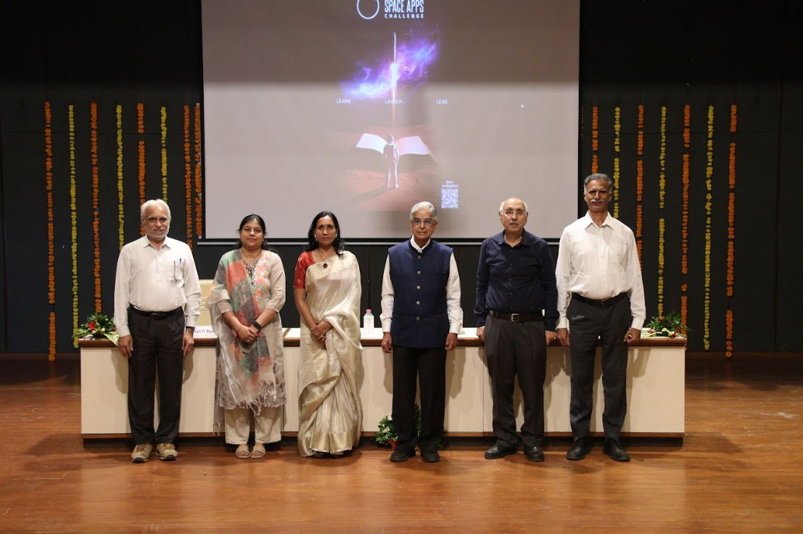
Esteemed Judge B N Suresh along with Director General Sir,Dr Mehul Naik,Ms Rashmika Shah,Mr Gajjar and Dr Priti Mehta
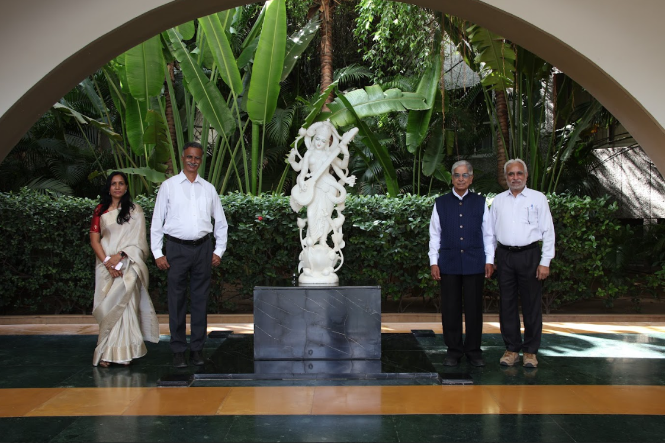
Dr B N Suresh along with DG Sir,Dr Mehul Naik,Ms Rashmika Shah and Mr Gajjar
Dr. B. N. Suresh, Chancellor of the Indian Institute of Space Science and Technology (IIST), Thiruvananthapuram, and Chairman of the Research Advisory Council (RAC) at the National Institute of Ocean Technology (NIOT), Chennai, is one of India’s most eminent scientists and visionaries. A close associate of Dr. A.P.J. Abdul Kalam, he played a pivotal role in the design and development of India’s launch vehicles such as SLV-3, ASLV, PSLV, GSLV Mk-II, and GSLV Mk-III, and led the Space Capsule Recovery Module (SRE) project. Recipient of the Padma Shri (2002), Padma Bhushan (2013), and over 25 national and international awards, Dr. Suresh’s contributions have been instrumental in advancing India’s space research and technology.

In his keynote address, Dr. Suresh delivered a deeply motivating and thought-provoking speech centered around innovation, teamwork, and self-reliance. He emphasized that India, already a global leader in intellectual potential, must now channel its capabilities toward technological and economic self-sufficiency. Drawing examples from India’s achievements in pharmaceutical innovation, the COVID-19 vaccine drive, and Unified Payment Interface (UPI), he highlighted how collective intelligence and innovation have transformed the nation’s global standing.
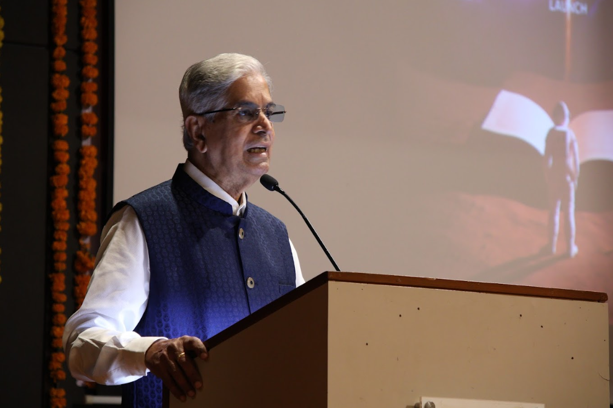
Inspirational Words by Dr B N Suresh

He also shed light on India’s forward-looking missions — the National Quantum Mission, semiconductor manufacturing initiatives, and upcoming space programs like Gaganyaan, the Bharatiya Space Station, and the Bharatiya Beta Beti lunar mission. Encouraging young minds to embrace interdisciplinary collaboration, he reminded participants, “A dream is not what you see when you sleep, but what does not let you sleep.”

During the interactive session, participants eagerly engaged with Dr. Suresh, asking insightful questions about India’s scientific and technological future. When asked how India could become a developed and modern nation, he emphasized that true progress depends on changing the national mindset and ensuring that the benefits of science reach every citizen.
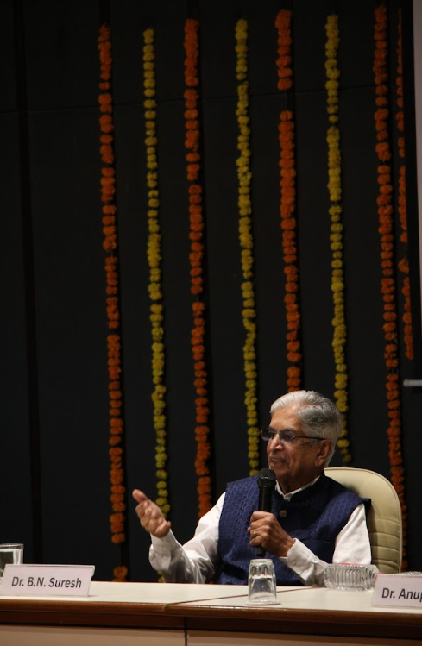
Q/A with Dr B N Suresh

In response to a question about the future of India’s space programs, Dr. Suresh spoke passionately about the country’s upcoming milestones — particularly Gaganyaan, which will send Indian astronauts into space, and the Bharatiya Space Station, which will establish India’s independent presence in low-Earth orbit. He reaffirmed Dr. Vikram Sarabhai’s vision that “every technological advancement must ultimately serve the common man.”

Another participant inquired about the role of Artificial Intelligence in space technology, to which Dr. Suresh explained that AI has become an essential part of mission design, data analysis, autonomous navigation, and spacecraft operation. He urged young engineers to develop strong foundations in AI, robotics, and data science, as these areas will define the next generation of space exploration and innovation.

In conclusion, Dr. Suresh urged students to stand firm in their goals and contribute to the nation’s growth, saying, “Stand on your own legs, choose your field with passion, and dedicate yourself to it. The next 25 years will define India’s place in the world — and you are the generation that will make it happen.”

Following his inspiring address, Ms. Rashmika Shah delivered the Vote of Thanks, expressing gratitude to Dr. Suresh, the dignitaries, mentors, and all attendees for making the inauguration a resounding success. A token of appreciation was presented to the Chief Guest as a mark of honor and respect.
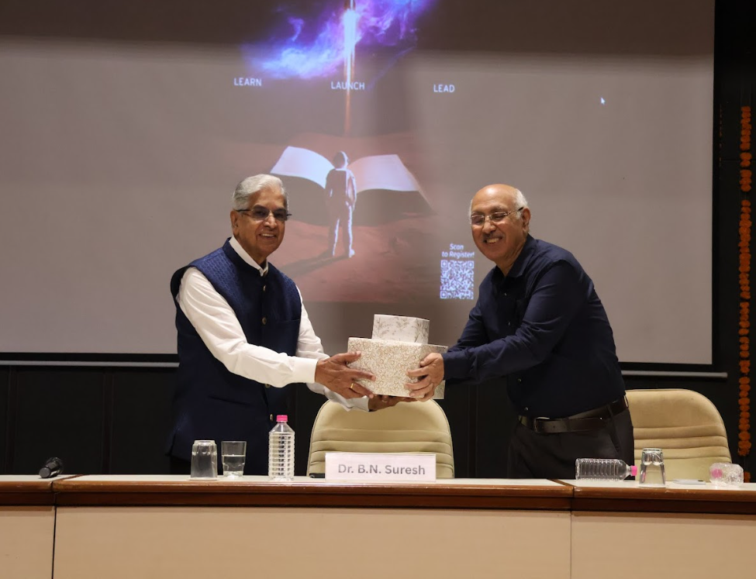
A token of respect presented by Director General Sir to Dr B N Suresh.
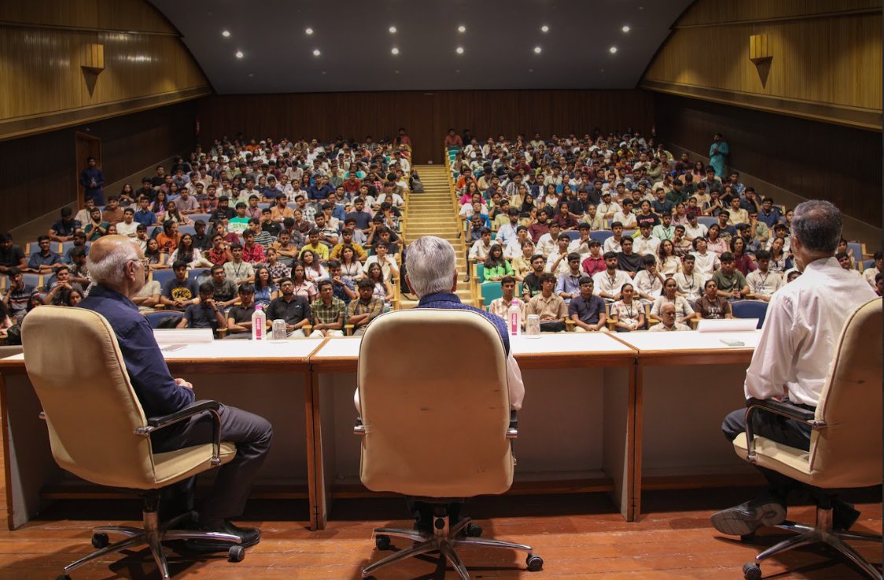
Inauguration Ceremony

By 12:00 PM, participants were allotted their workstations, marking the beginning of the hackathon. Shortly after, Dr. Suresh visited the teams, interacting with participants, reviewing their initial ideas, and offering words of encouragement.

Brainstorming and Mentoring Session
Following the insightful inauguration ceremony, the NASA Space Apps Challenge 2025 at Nirma University seamlessly transitioned into an atmosphere of creativity and collaboration as participants began working on their challenge statements.

The brainstorming session, held from 12:00 PM to 1:00 PM, served as the first major step toward ideation. During this hour, participants actively discussed their assigned problem statements, analyzed datasets provided by NASA, and formulated initial concepts for their projects.
A lunch break followed from 1:00 PM to 2:00 PM, allowing participants to refresh and network informally with peers and mentors. The university’s vibrant ambiance, filled with creativity and excitement, encouraged meaningful conversations and cross-disciplinary learning.
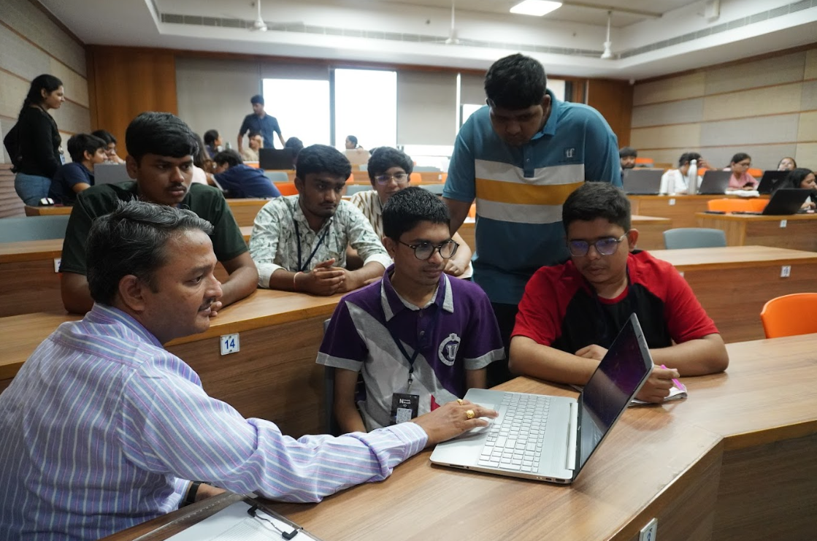
Mentoring by Dr K Venkatesh

Post-lunch, the mentoring session commenced from 2:00 PM to 6:00 PM. This session was one of the most valuable segments of Day 1, where participants received expert guidance from a distinguished panel of mentors. The mentors not only provided technical insights but also evaluated the teams based on their ideation and team coordination and strategies, offering constructive feedback to strengthen their projects.
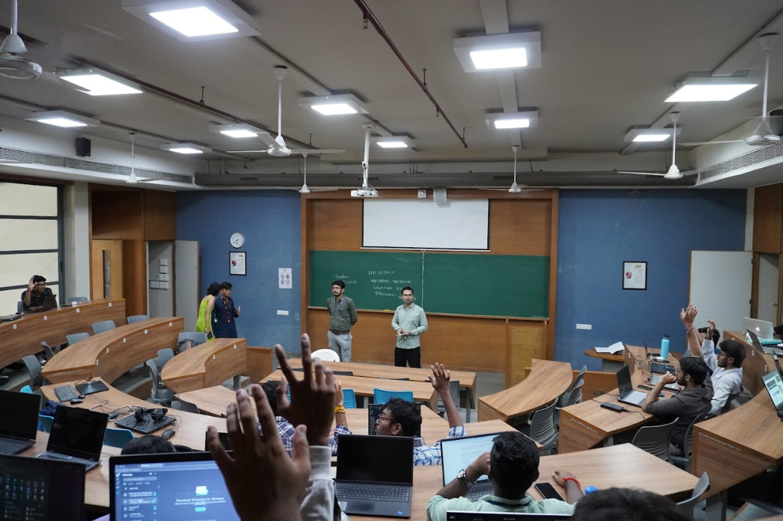
Brainstorming

The mentor panel included highly respected professionals and industry experts such as Pankaj Budani, Shiv Mohan, Hamish D’Souza, Dibyendu Chakrabarty, Dr. K. Venkatesh, Utkarsh Tyagi, Jinanshi Shah, Vivek Shah, Ankit Didwania, Tanmaye Vyas, Dhruv Panchal, Aviral Singhal, Yash Bhatt, and Tatsat Thakore. Each mentor was assigned to specific problem statements based on their domain expertise, ensuring that every team received targeted and practical guidance. The interaction between mentors and teams encouraged participants to refine their technical approaches, think critically, and align their solutions with real-world applications.
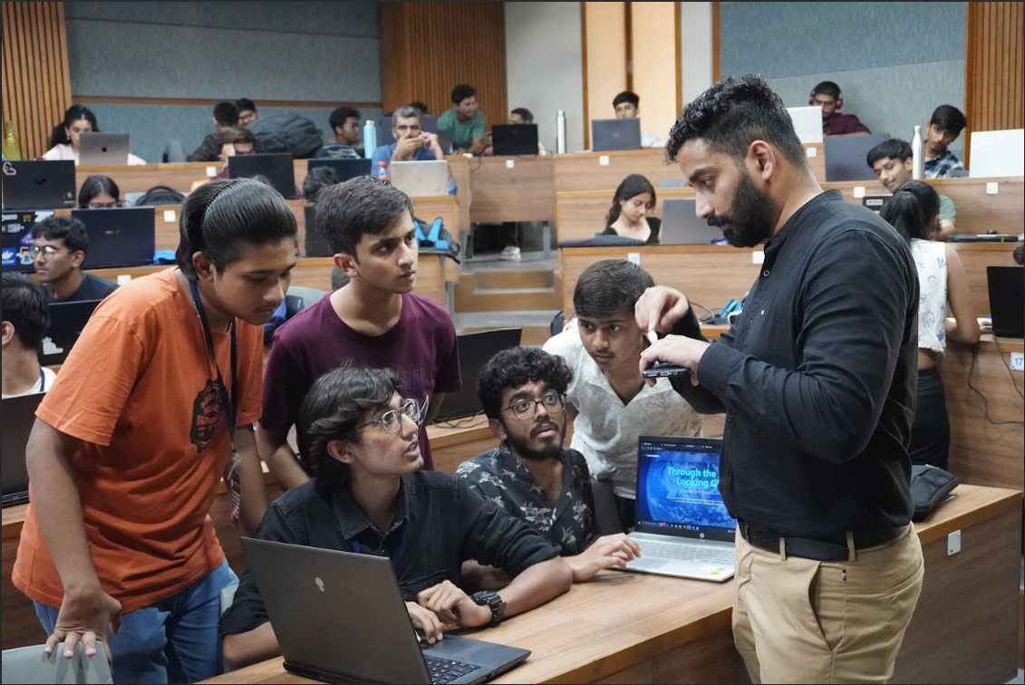
Mentoring by Mr. Hamish D’souza

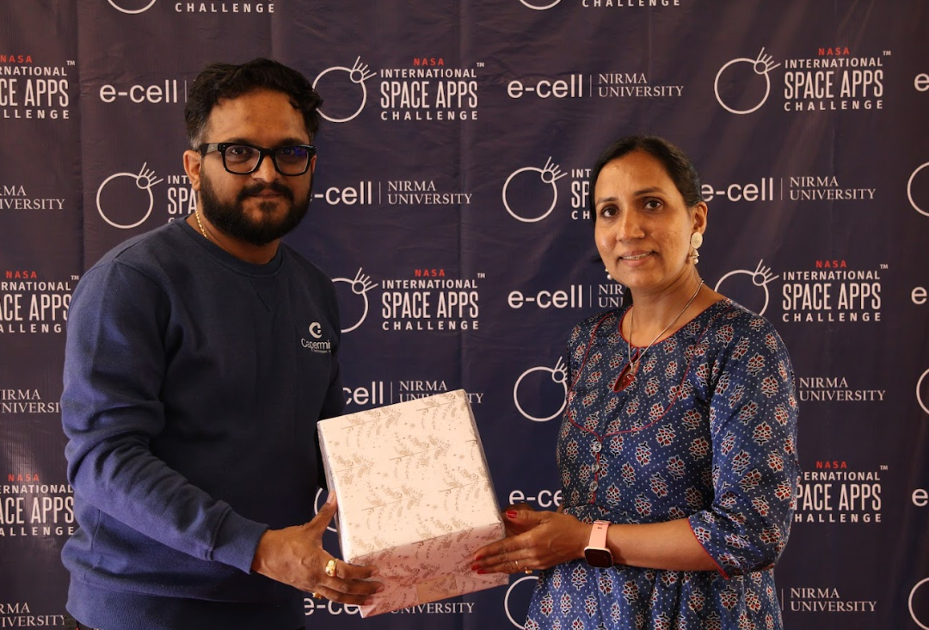
Memento given to Mr.Vivek Shah
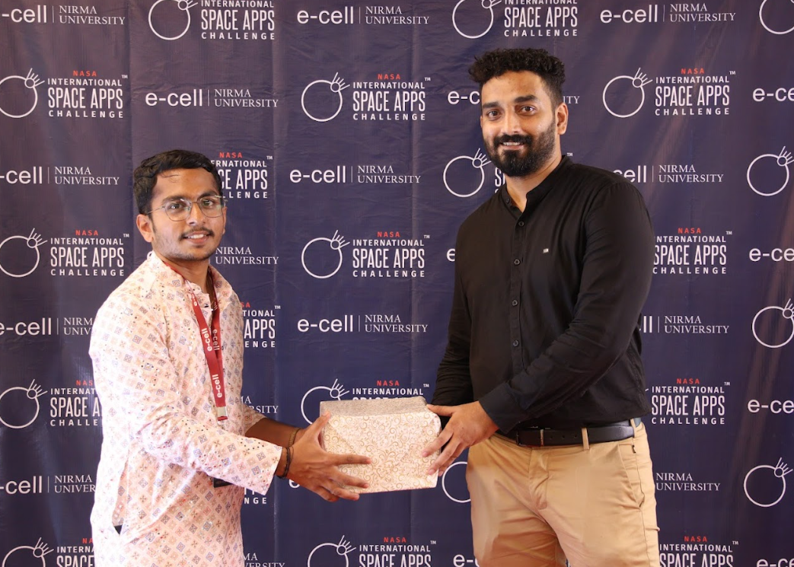
A token of respect presented to Mr Hamish D’souza
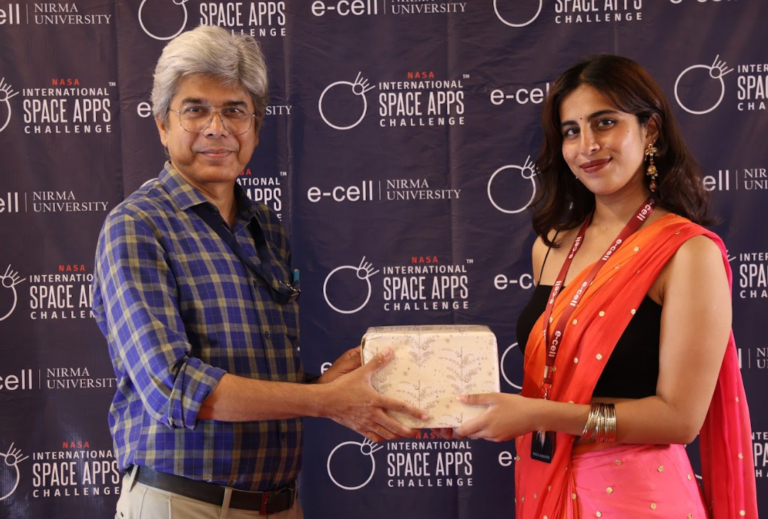
A token of respect presented to Mr Dibyendu Chakraborty
In addition to the intense work sessions, a photo booth and fun games were thoughtfully arranged to help participants unwind and rejuvenate amidst the demanding schedule. These interactive activities fostered team bonding, creativity, and a relaxed environment — balancing productivity with enjoyment.
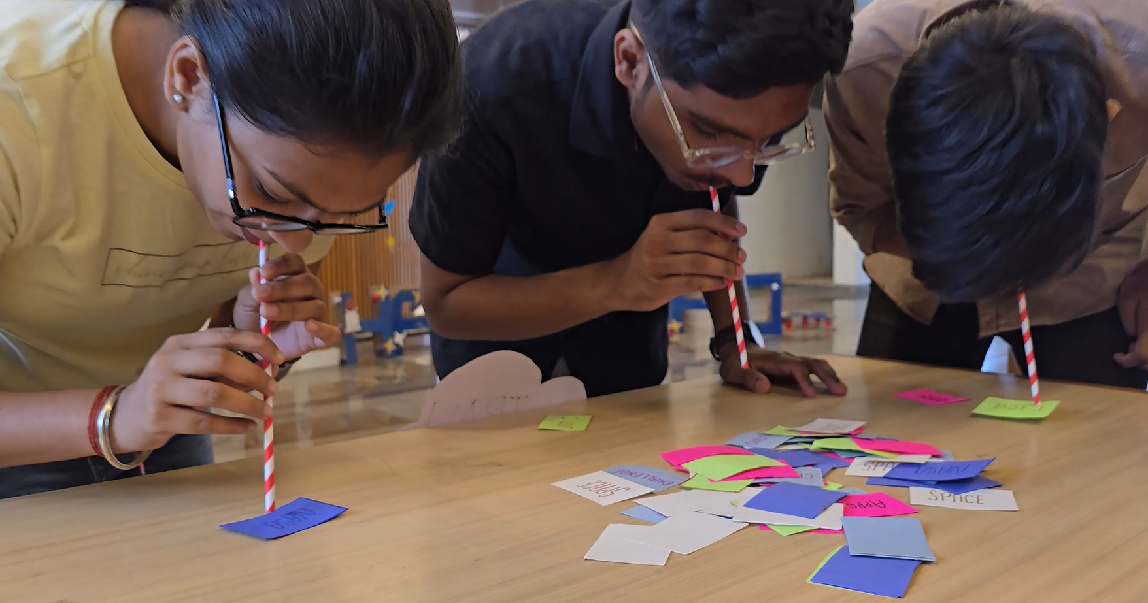
Fun games

The first day concluded successfully at 6:00 PM, marking a productive and inspiring start to the hackathon. By the end of Day 1, teams had developed clear directions for their projects, benefited from expert mentorship, and built strong collaborative spirits

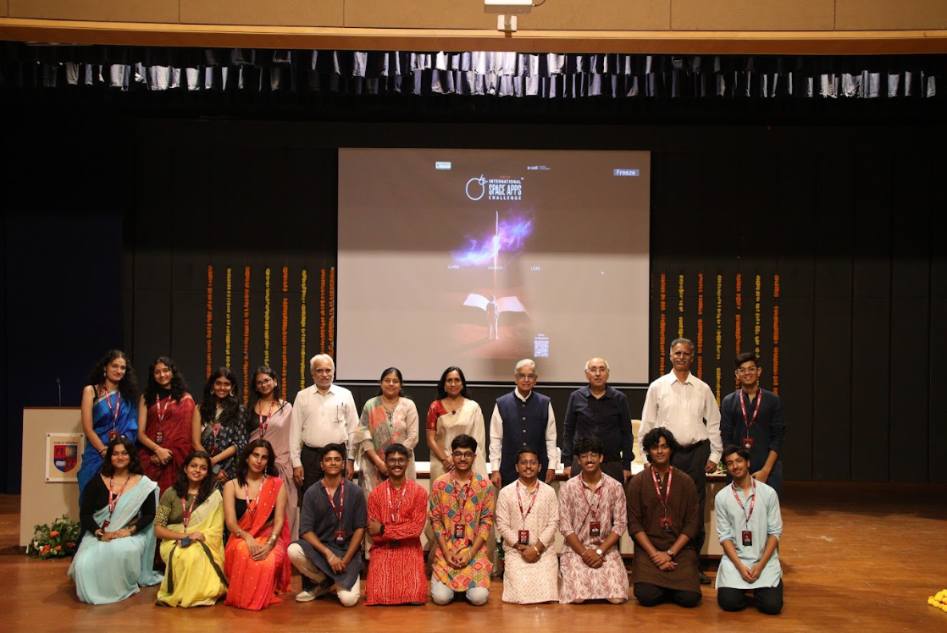
Team E-cell with respected Dr.B N Suresh

DAY 2
Brainstorming, Mentoring session,Jamming Session
Timings:9:00 am to 6:00 pm
Venue: E-Block Classrooms

Day 2 of the NASA Space Apps Challenge 2025 at Nirma University focused on mentoring, brainstorming, and project development, providing participants with both guidance and hands-on experience. The day began with a structured session from 9:00 AM to 1:00 PM, during which teams engaged deeply with their assigned problem statements. Participants brainstormed, refined their ideas, and worked closely with the panel of expert mentors to ensure their solutions were innovative, practical, and technically robust.
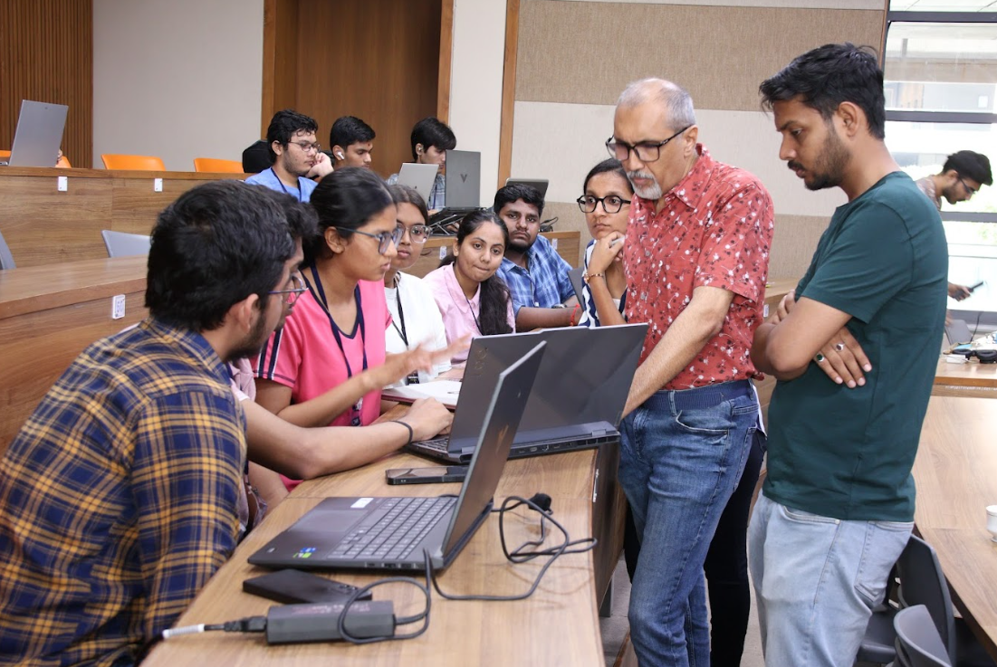
Mentoring by Mr Tanmaye Vyas
The mentoring panel comprised distinguished professionals including Pankaj Budani, Shiv Mohan, Hamish D’Souza, Dibyendu Chakrabarty, Dr. K. Venkatesh, Utkarsh Tyagi, Jinanshi Shah, Vivek Shah, Ankit Didwania, Tanmaye Vyas, Dhruv Panchal, Aviral Singhal, Yash Bhatt, and Tatsat Thakore. Each mentor was assigned to specific teams according to their expertise and provided guidance, constructive feedback, and evaluation, helping participants refine their projects effectively. In recognition of their valuable contribution, all mentors were presented with mementos as a token of respect and appreciation for their guidance and support.
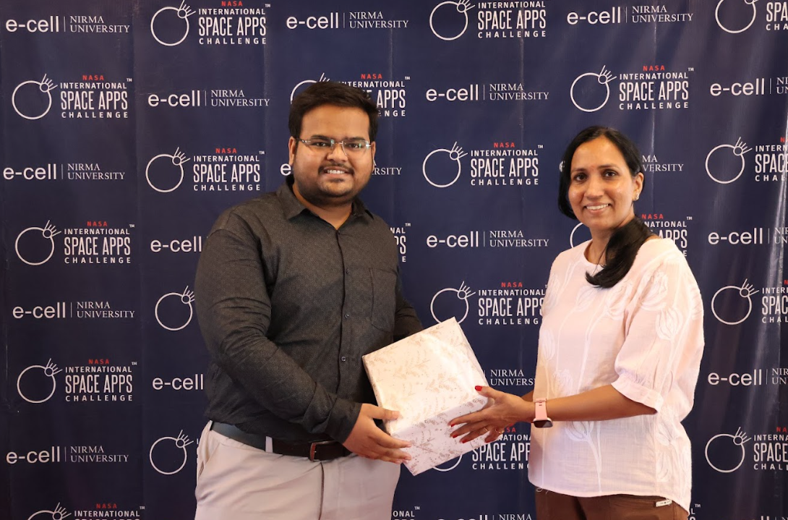
A token of respect presented to Mr Dhruv Panchal
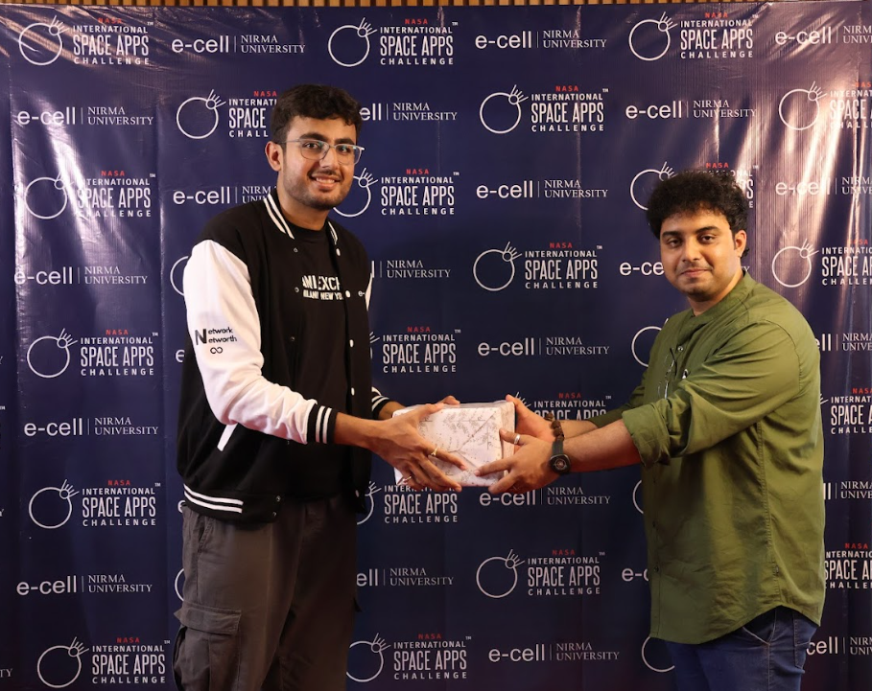
A token of respect presented to Mr Tatsat Thakore
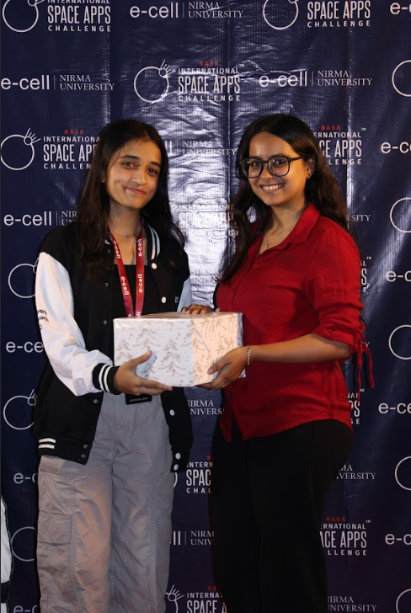
A token of respect presented to Ms Jinanshi Shah
During the morning and early afternoon, teams focused on developing their projects, preparing presentations (PPTs) and videos for submission on the official NASA Space Apps platform.
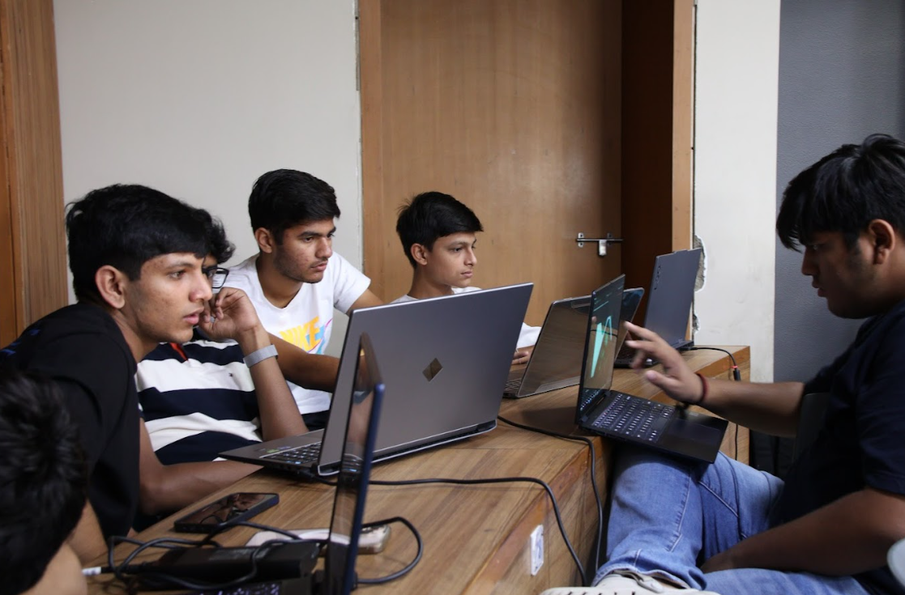
Brainstorming time

To offer a refreshing break from intensive work, participants engaged in various fun games and recreational activities, which fostered team bonding, creativity, and rejuvenation. Later, at 5:00 PM, the Swaraag Band from Nirma University performed a lively jamming session, providing an energetic and enjoyable interlude that uplifted the spirits of all participants.
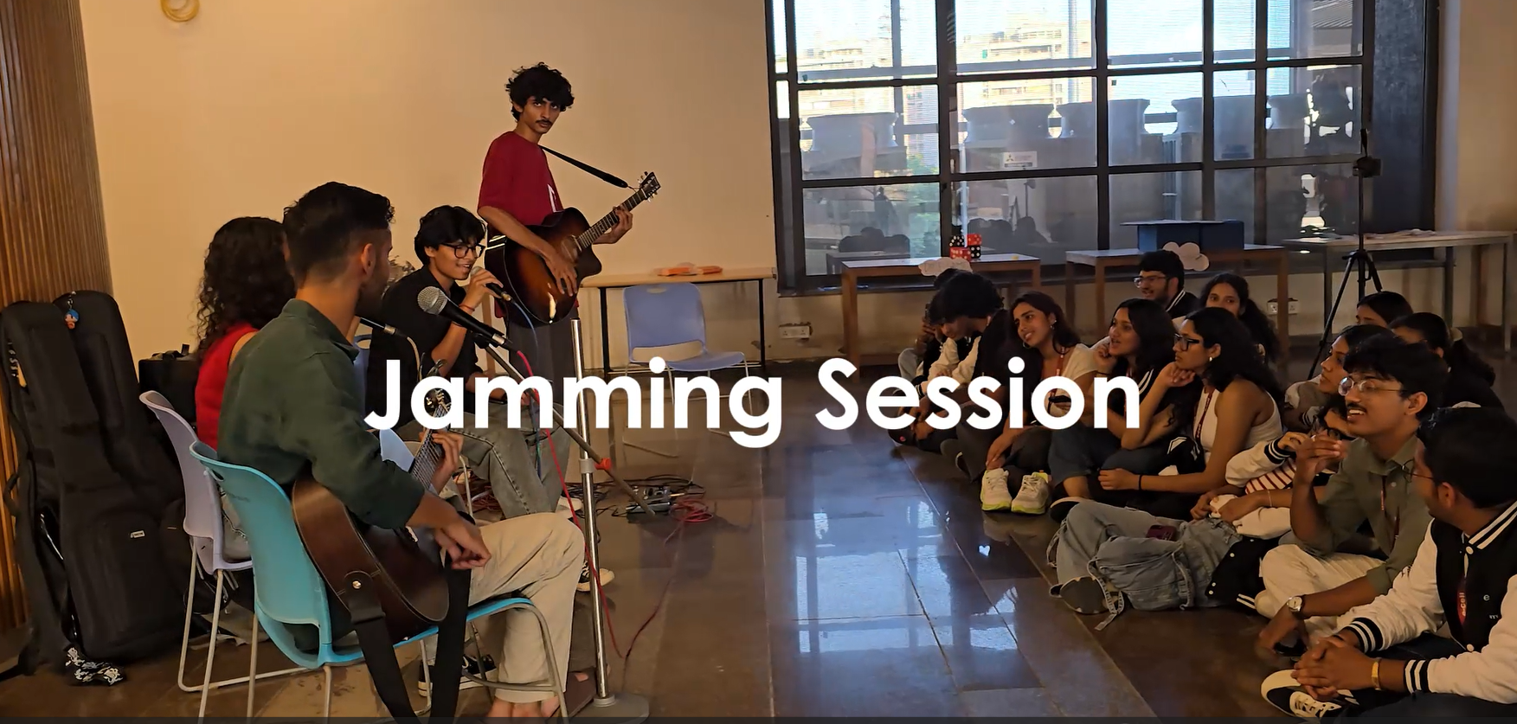
Day 2 successfully balanced mentorship, hands-on project development, and recreational engagement, enabling teams to refine their solutions while fostering collaboration, creativity, and a sense of community.

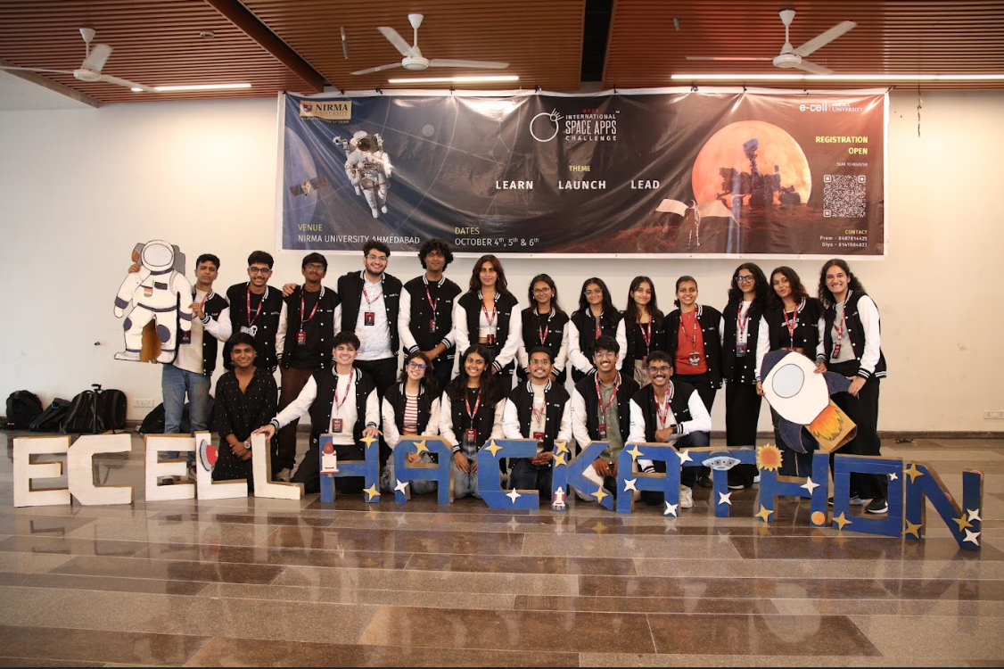
Team E-cell

DAY 3
Grand Finale
Timing:9:00 am to 1:30 pm
Venue: C-Auditorium

The third and final day of the NASA Space Apps Challenge 2025 at Nirma University was dedicated to the local round presentations and the announcement of winners. The day commenced with a prayer, setting a focused and enthusiastic tone for the concluding session. The top 15 teams, selected based on their performance over the first two days, presented their solutions to a distinguished panel of judges.
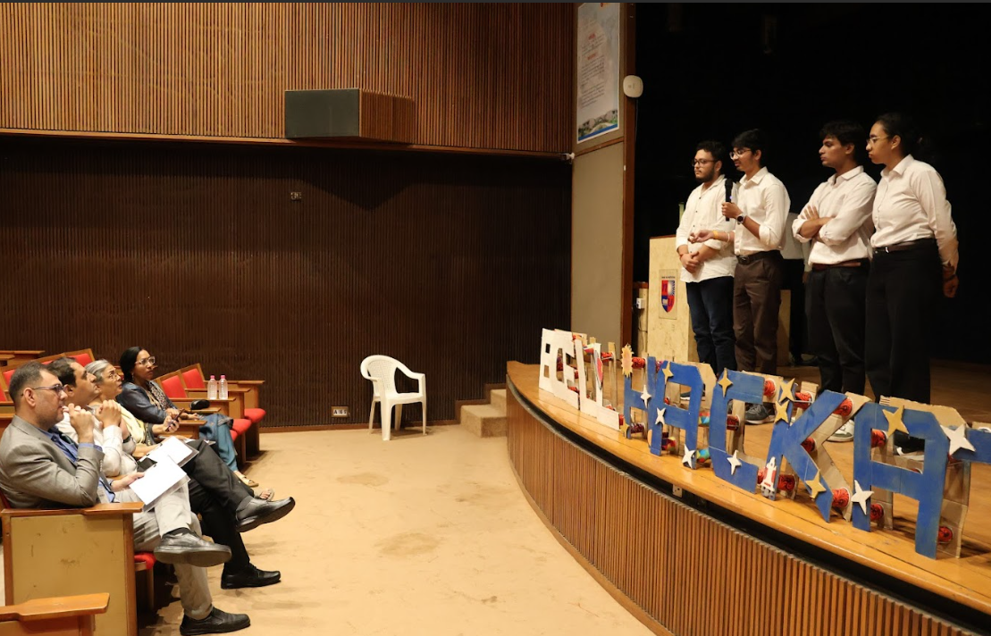
Q/A session
The judges for the event were eminent space professionals with extensive experience and expertise:

Mr. Nikhil Arora – An accomplished space professional with over 15 years of experience in spacecraft operations and management, Mr. Arora has played key roles in major satellite missions, including Deputy Project Director for EOS-04 and Deputy Operation Director for RISAT-2. He currently serves at the Technical Directorate at IN-SPACe, supporting startups, mentoring academia, and driving innovation in space programs.
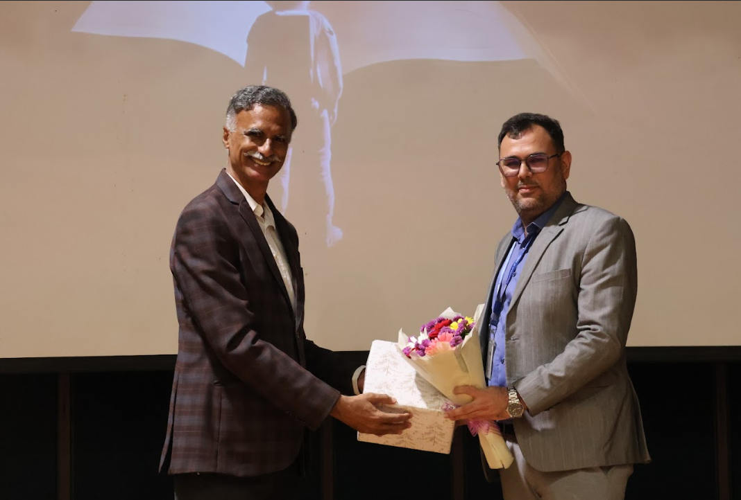
A token of love presented to Mr Nikhil Arora
Dr. Parul Patel – A distinguished space scientist and academic, Dr. Patel is the Former Group Director at ISRO and has contributed significantly to India’s space missions. She earned her Ph.D. in SAR Polarimetry at Nirma University, making her presence at her alma mater particularly special.
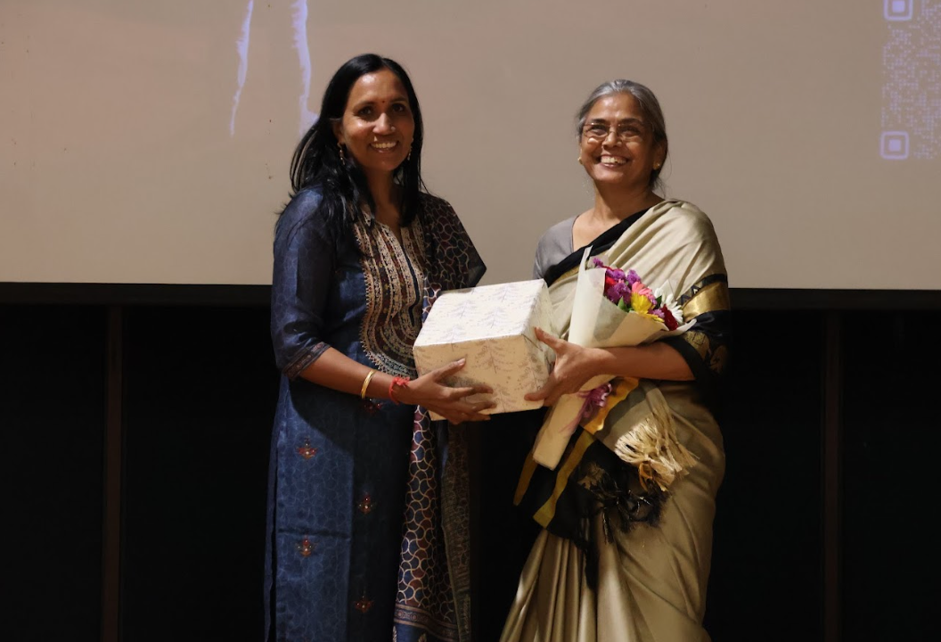
A token of love presented to Dr Parul Patel
Mr. Parimal Govani – With over 24 years at ISRO, Mr. Govani is currently the Deputy Project Director at the Space Applications Centre, having contributed to missions such as RISAT-1A and INSAT-3DS. His leadership and technical expertise have been pivotal in advancing India’s space technology initiatives.
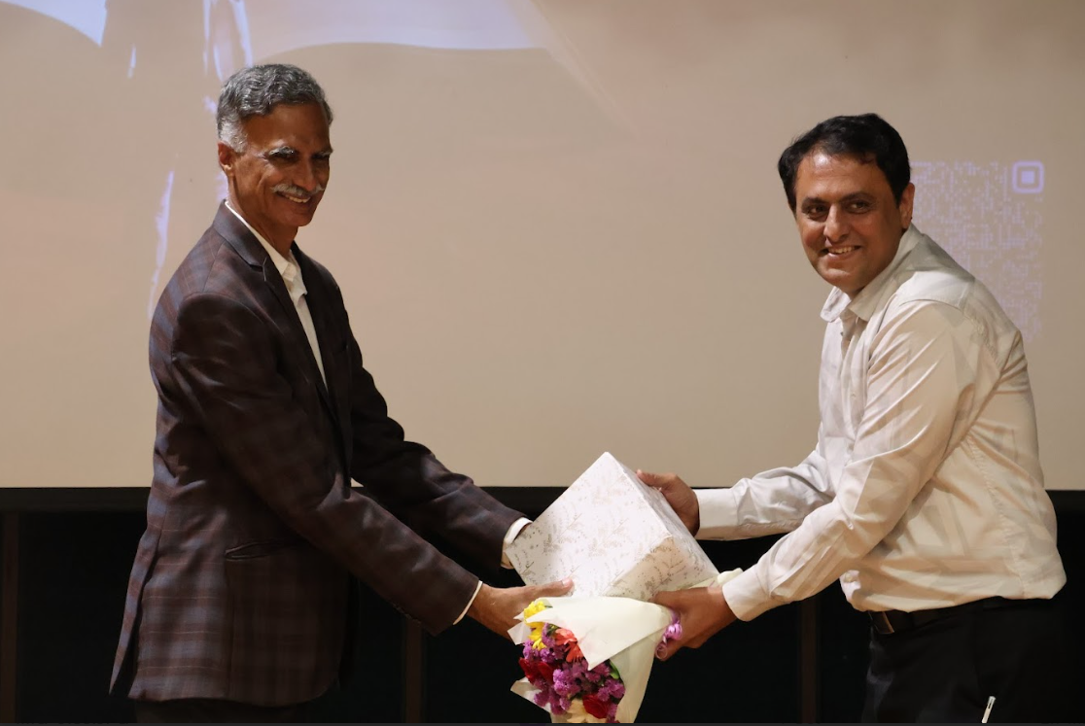
A token of love presented to Mr Parimal Govani
Each team was allotted 5 minutes for presentation and 6 minutes for a question-and-answer round, allowing the judges to evaluate their technical accuracy, innovation, and practical impact. Teams presented diverse projects, including AI-powered exoplanet detection, urban planning platforms, precision agriculture software, and weather prediction tools.
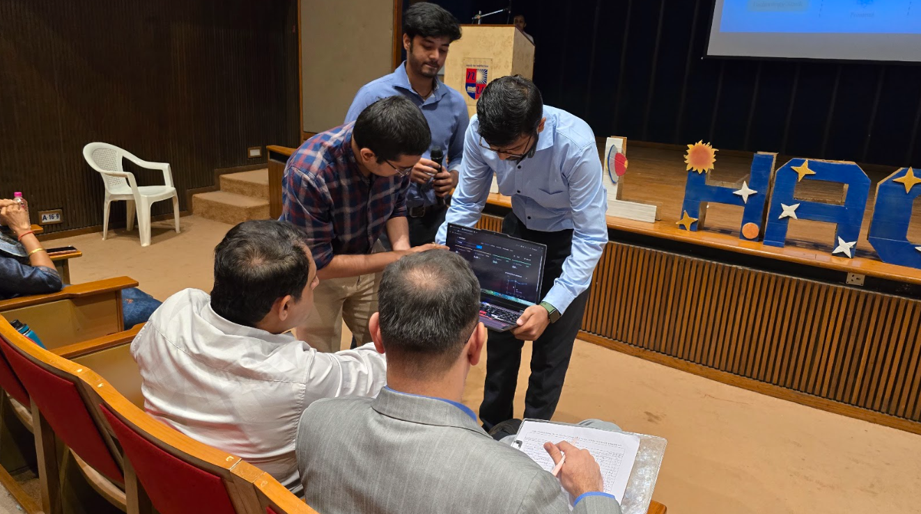

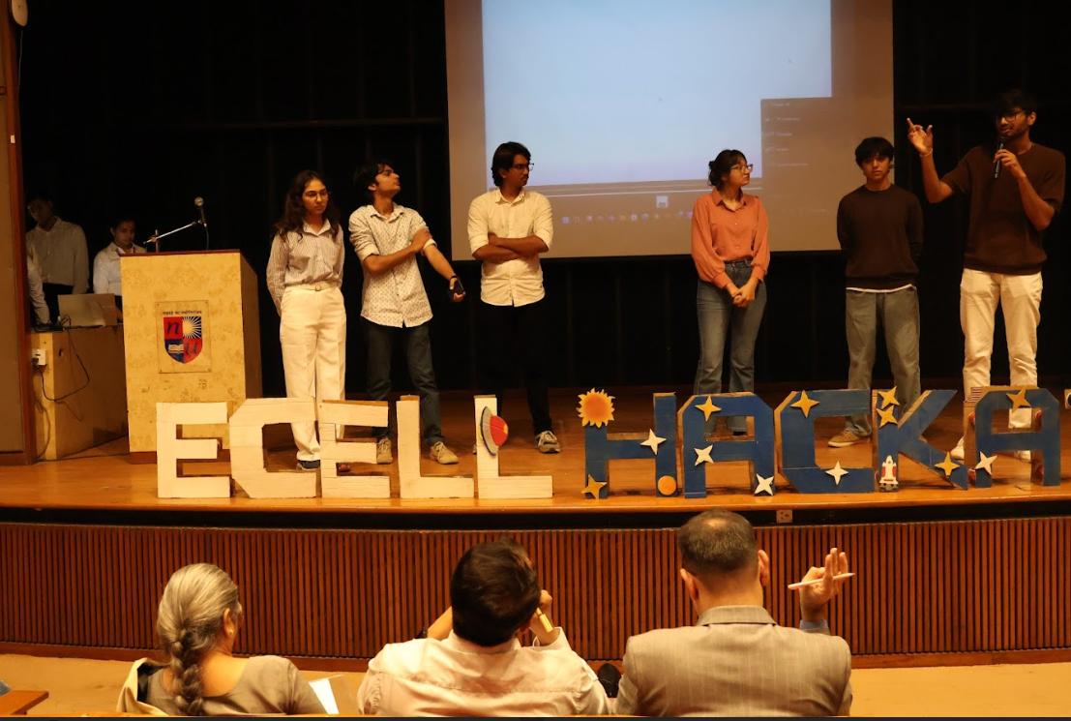
Presentation by Team Zypher

The judges provided constructive feedback, appreciating innovation while offering suggestions to improve presentation clarity and cross-questioning skills. In recognition of their guidance, all judges were presented with mementos as a token of respect.

The day concluded with the announcement of winners and a heartfelt Vote of Thanks from the organizing team. Day 3 successfully celebrated the creativity, dedication, and collaborative spirit of participants.
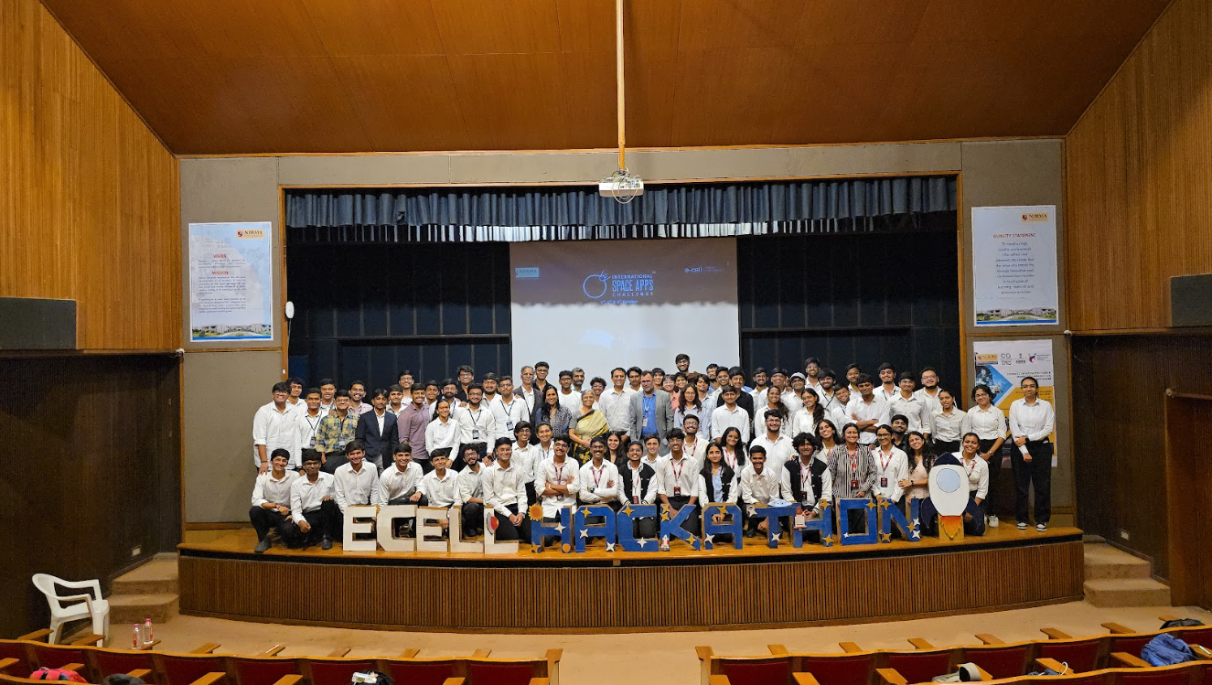
Team E-cell with participants and judges

WINNERS
Team Zypher,Government Polytechnic College and LJ College emerged as the winner of the local round.Team Zypher focused on exoplanet research and aimed to explore the possibility of life on exoplanets. They combined two datasets, addressing the high missing value issue in the K2 dataset (over 80% missing data) to ensure more reliable analysis. Their project included an integrated chatbot, allowing interactive questioning about their research and findings. The team also presented a video demonstration showcasing their work, which impressed the judges and helped them emerge as the winners.
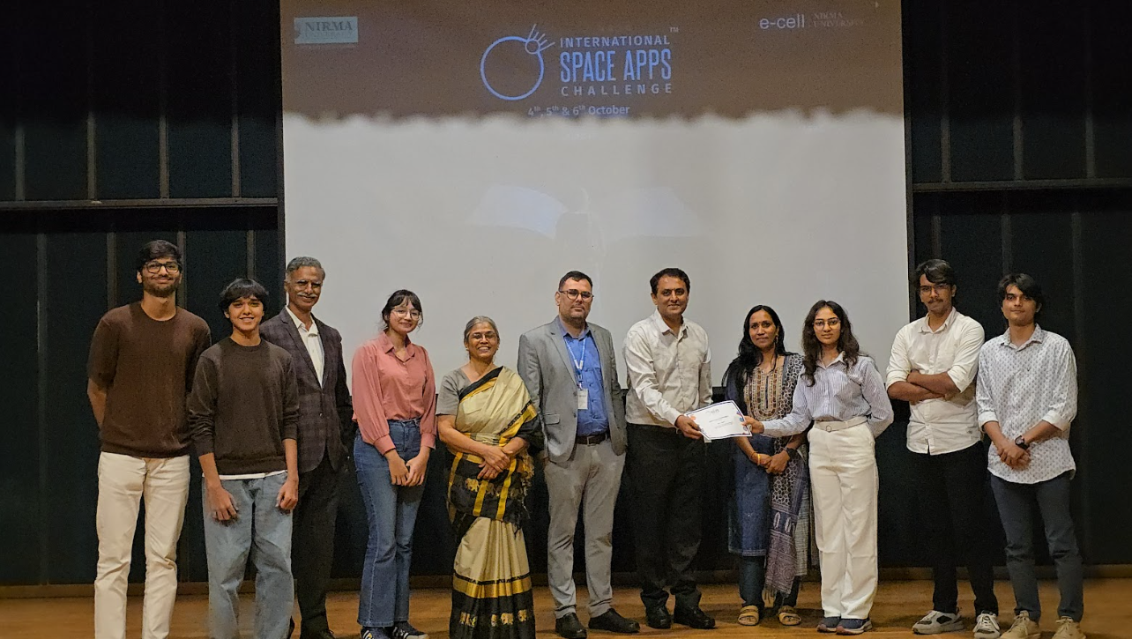
Team Zypher emerged as the winner
Team NEIL A,Nirma University emerged as 1st runner up.They addressed LEO commercialization with smart Hives that recycle orbital debris into raw materials and provide on-demand in-orbit manufacturing.Using NASA data and ORDEM for Hive placement and tracking, their dual capture system-robotic arms plus tag-and-tow tether -efficiently harvests materials.
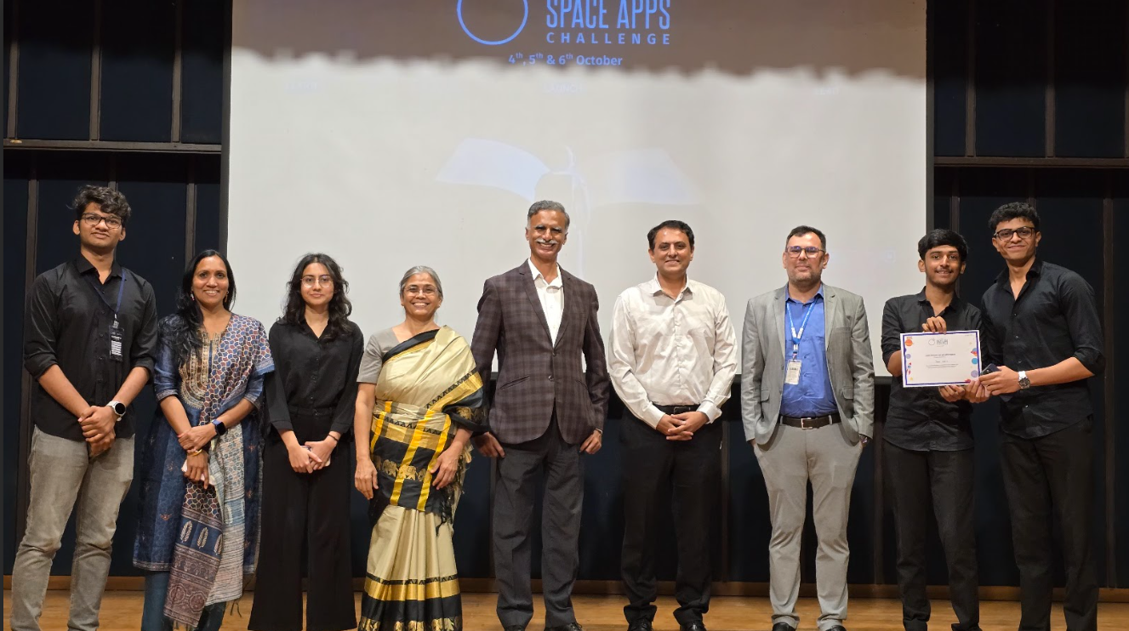
Team NEIL A emerged as 1st runner up
Team Astro Coders,LD College of Engineering emerged as 2nd runner up.They focused on space data analysis and solutions (or specify exact project if known), leveraging innovative approaches to address challenges in space exploration. Their work impressed the judges and earned them the third-place position.

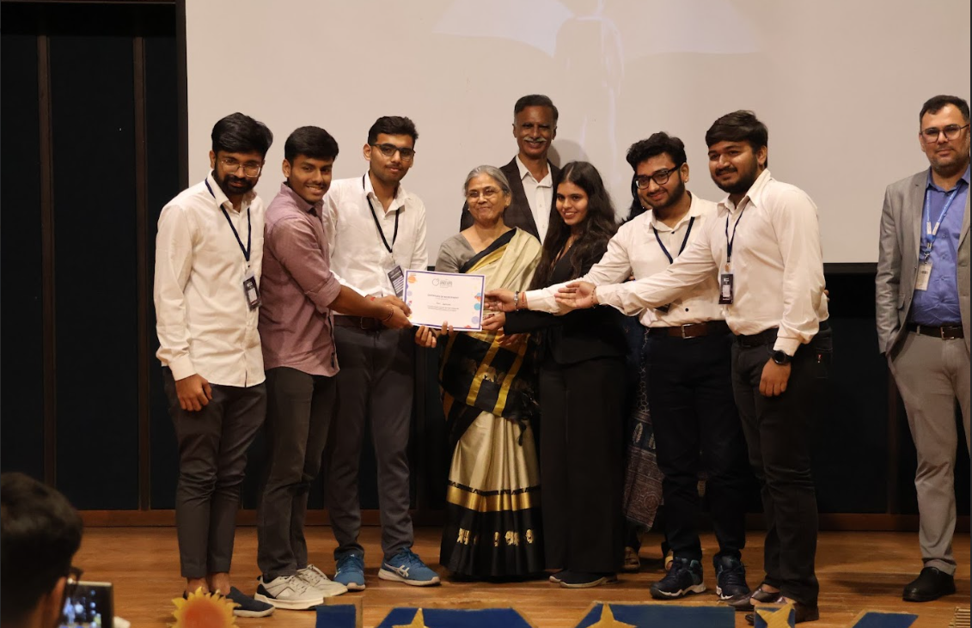
Team Astrocoders emerged as 2nd runner up

